**5G ARENA**

**A PROJECT REPORT**

***Submitted by***

**VIMAL.C 727822TUEC254**

***in partial fulfillment for the award of the degree of***

### BACHELOR OF ENGINEERING IN

**DEPARTMENT OF ELECTRONICS AND**

**COMMUNICATIONENGINEERING**

**FEBRUARY 2023**

**BONAFIDE CERTIFICATE**

Certified that this project report **“5G ARENA”** is the bonafide work of

**“VIMAL C”** who carried out the project work under my supervision.

**SIGNATURE SIGNATURE**

**Ms.SANGEETHA Dr.SHANTHI**

**SUPERVISOR HEAD OF THE DEPARTMENT**

Assistant Professor, Professor,

Department of Information Department of Electronics and

Technology Communication Engineering

Sri Krishna College of Technology, Sri Krishna College of Technology,

Coimbatore-641042. Coimbatore-641042.

Certified that the candidate were examined by us in the Project Work Viva Voce examination held on____________at Sri Krishna College of Technology, Kovaipudur, Coimbatore -641042

**INTERNAL EXAMINER EXTERNAL EXAMINER**

***ACKNOWLEDGEMENT***

### ACKNOWLEDGEMENT

First and foremost, I thank the **Almighty** for being our light and for showering his gracious blessings throughout the course of this project.

I am grateful to our beloved Dean-Academics **Dr.Manju P &** Dean-Administration **Dr.R.Ramesh Kumar** for their tireless and relentless support.

I extend my sincere thanks to our Head of the Department **Dr.Shanthi** for her encouragement and inspiration.

We are greatly indebted to our Industry Mentor **--------------------**& Project guide **Ms.Sangeetha** Assistant Professor, Department of Information Technology for their valuable guidance and suggestions in all aspects that aided us to ameliorate our skills.

We are thankful to all those who have directly and indirectly extended their help to us in completing this project work successfully.

# ABSTRACT



## ABSTRACT

5G Arena aims to provide a comprehensive evaluation of the mobile sales website. The website offers a wide range of latest 5G from various manufacturers and aims to simplify the mobile buying process for customers. It focuses on the website's key features, including user interface and navigation, product offerings, customer reviews and ratings, financing options, and customer service and support. It analyzes the advantages and potential areas for improvement of the website, providing valuable insights for the customers. By evaluating the website's ability to meet the needs and expectations of customers, it aims to provide recommendations on how the website can better serve its audience. It serves as a valuable resource for anyone interested in the online presence and functionality of the mobile sales dealership.

# TABLE OF CONTENTS



### TABLE OF CONTENT

|  |  |  |
| --- | --- | --- |
| **CHAPTER NO** | **TITLE** | **PAGE NO** |
| 1 | **INTRODUCTION** | 1 |
|  | 1.1 PROBLEM STATEMENT | 2 |
|  | 1.2 OVERVIEW | 2 |
|  | 1.3 OBJECTIVE | 2 |
| 2 | **SYSTEM SPECIFICATIONS** | 3 |
| 3 | **PROPOSED SYSTEM** | 5 |
|  | 3.1 PROPOSED SYSTEM | 5 |
|  | 3.2 ADVANTAGES | 6 |
| 4 | **METHODOLOGIES** | 7 |
|  | 4.1 LOGIN PAGE | 7 |
|  | 4.2 SIGN UP PAGE | 8 |
|  | 4.3 MOBILES PAGE | 9 |
|  | 4.4 HOME PAGE | 10 |
|  | 4.5 PAYMENT PAGE | 11 |
| 5 | **IMPLEMENTATION AND RESULT** | 12 |
|  | 5.1 LOGIN PAGE | 12 |
|  | 5.2 SIGN UP PAGE | 13 |
|  | 5.3 MOBILES PAGE | 14 |
|  | 5.4 HOME PAGE | 15 |
|  | 5.5 PAYMENT PAGE | 16 |
| 6 | **CONCLUSION AND FUTURE SCOPE** | 34 |
|  | 6.1 CONCLUSION | 34 |
|  | 6.2 FUTURE SCOPE | 34 |
| 7 | **REFERENCES** | 35 |

***LIST OF FIGURES***



vi

### LIST OF FIGURES

|  |  |  |
| --- | --- | --- |
| **Figure No** | **TITLE** | **Page No** |
| 4.1 | Process flow diagram | 7 |
| 4.2 | Login page flowchart | 8 |
| 4.3 | Signup page flowchart | 9 |
| 4.4 | Mobiles page flowchart | 10 |
| 4.5 | Payment flowchart | 11 |
| 5.1 | Login page | 12 |
| 5.2 | Signup page | 13 |
| 5.3 | Mobiles page | 14 |
| 5.4 | Home page | 15 |
| 5.5 | Payment page | 16 |
| 5.6 | Confirmation page | 17 |

***LIST OF ABBREVIATIONS***



vii

### LIST OF ABBREVIATIONS

### 

|  |  |
| --- | --- |
| ABBREVATION | ACRONYM |
| HTML | Hypertext Markup Language |
| CSS | Cascading Style Sheet |
| JS | Javascript |

### 

# INTRODUCTION



1

## CHAPTER 1

## INTRODUCTION

5G Arena aims to evaluate the online presence and functionality of 5G Arena, a platform that offers a wide range of Mobiles from various manufacturers to meet the diverse needs of mobile buyers. The purpose of this website is to provide a comprehensive analysis of the website's key features, including its user interface and navigation, product offerings, customer reviews and ratings, financing options, and customer service and support.

It will also offer recommendations on how the website can improve its overall performance and provide a better user experience for customers. By analyzing the website's strengths and weaknesses, this report will serve as a valuable resource for both the mobile dealership and potential mobile buyers. It aims to provide an in-depth analysis of the website and its ability to meet the needs and expectations of its customers.

It analyzes the advantages and potential areas for improvement of the website, providing valuable insights for both the mobile dealership and its customers. It also gives the user the freedom to choose his desired page without any restrictions . By evaluating the website's ability to meet the needs and expectations of customers, it aims to provide recommendations on how the website can better serve its audience.

2

### PROBLEM STATEMENT

The smartphone industry is rapidly evolving, and mobile dealers are facing increasing pressure to provide a seamless and convenient online shopping experience for customers. Despite the growing importance of online mobile shopping, many mobile sales websites are not optimized to meet the needs and expectations of today's mobile buyers.

### OVERVIEW

The 5G Arena is a mobile sales platform that offers a wide range of mobiles from various manufacturers to meet the diverse needs of mobile buyers. The website aims to provide a convenient, efficient, and informative mobile buying experience for customers, helping the customer to choose which mobile is best suited for their requirements and expectations.

### OBJECTIVE

The objective of this report is to evaluate the 5G Arena, a mobile sales platform, and provide recommendations for enhancing its online capabilities and customer experience. This includes analyzing the website's user interface and navigation, product offerings, customer reviews and ratings, financing options, and customer service and support. The ultimate goal is to identify areas for improvement and provide insights to help the website better serve its customers and drive sales.

# 

# SYSTEM SPECIFICATION



## CHAPTER 2

## SYSTEM SPECIFICATION

In this chapter, we are going to see the softwares that we have used to build the website. This chapter gives you a small description about the softwares used in the project.

### 2.1 VS CODE

Visual Studio Code is a source code editor developed by Microsoft for Windows, Linux, and macOS. It includes support for debugging, embedded Git control, syntax highlighting, intelligent code completion, snippets, and code refactoring. It is also customizable, so users can change the editor's theme, keyboard shortcuts, and preferences.

Visual Studio Code includes a powerful auto-complete feature, which suggests code as the developer types, reducing the likelihood of syntax errors. The editor also includes linting and debugging tools, allowing developers quickly identify and fix coding issues. It has built-in support for JavaScript, and enables developers to quickly move between files and view detailed type definitions. It also has a built-in terminal for running tasks. Additionally, VS Code has an extensive library of extensions that allow developers to quickly add features like code snippets, debugging tools, and linting support to their projects.

Visual Studio Code is a popular code editor that is widely used by web developers for HTML and CSS development. It provides a user-friendly interface with a variety of that make coding easier and more efficient. Visual Studio Code includes a powerful auto-complete feature, which suggests code as the developer types, reducing the likelihood of syntax errors. The editor also includes linting and debugging tools, allowing developers quickly identify and fix coding issues. In addition, Visual Studio Code supports a variety extensions and plugins that can be used to enhance its functionality.

### LOCAL STORAGE

Local storage is a type of web storage for storing data on the client side of a web browser. It allows websites to store data on a user’s computer, which can then be accessed by the website again when the user returns. Local storage is a more secure alternative to cookies because it allows websites to store data without having to send it back and forth with each request. Local storage is a key-value pair storage mechanism, meaning it stores data in the form of a key and corresponding value. It is similar to a database table in that it stores data in columns and rows, except that local storage stores the data in the browser rather than in a database. Local storage is often used to store user information such as preferences and settings, or to store data that is not meant to be shared with other websites. It is also used to cache data to improve the performance of a website. Local storage is supported by all modern web browsers, including Chrome,

Firefox, Safari, and Edge. It is accessible through the browser’s JavaScript . Local storage is a powerful tool for websites to store data on the client side. It is secure, efficient, and can be used to store data that does not need to be shared with other websites.

# PROPOSED SYSTEM



## CHAPTER 4

## PROPOSED SYSTEM

This chapter gives a small description about the proposed idea behind the development of our website

### PROPOSED SYSTEM

Based on the analysis and evaluation of the 5G Arena mobile sales platform, the following recommendations are proposed to improve the online customer experience and drive sales. Enhance User Interface and Navigation: The website's user interface should be modern, intuitive, and user-friendly, making it easy for customers to find the information and features they need. The navigation should be clear and straightforward, with categories and filters to help customers quickly find the mobiles they are interested in.

The website should offer a wide range of latest mobiles from various manufacturers, with detailed information and photos for each mobile. The website should also incorporate customer feedback and ratings to improve the quality and presentation of its product offerings. The website should offer convenient and accessible financing options, including online financing, to make the mobile buying process as easy as possible for customers.

The financing options should be integrated into the mobile buying process, allowing customers to complete the entire process on the website. The website should offer various channels for customers to get help and support, including online chat, FAQs, and contact information. The customer service and support should be responsive, helpful, and accessible to meet the needs of customers.

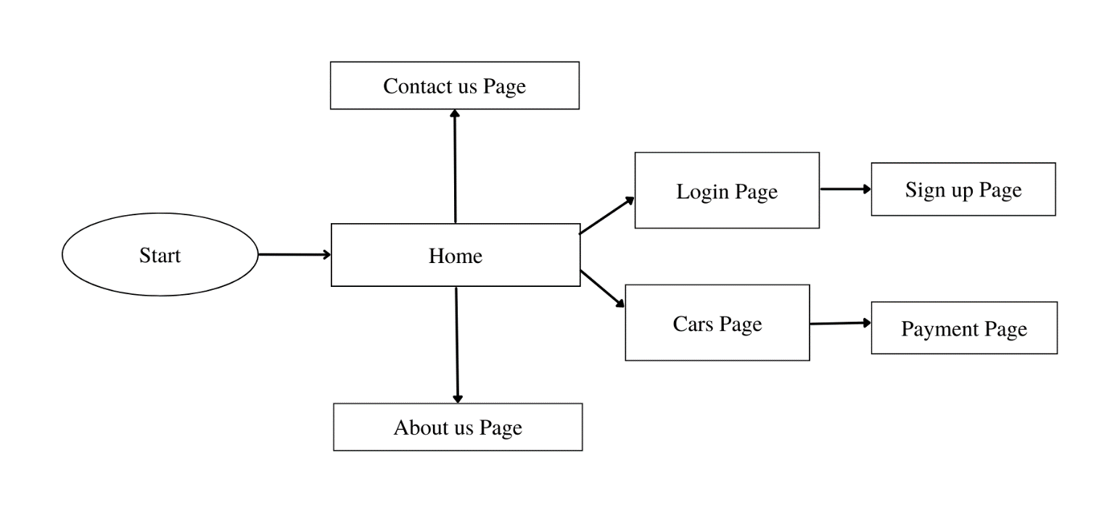

4.1 PROCESS FLOW FLOWCHART

### ADVANTAGES

* Convenience: A mobile sales website offers the convenience of shopping for a mobile from the comfort of one's home which can also act as a useful mobile buying guide.
* Increased Product Visibility: A well-designed website showcases the mobile’s entire specifications providing customers with a comprehensive view of all the available mobiles.
* Time-saving: With a mobile sales website, customers can save time by researching and comparing mobiles online before visiting the dealership in person.
* Improved Customer Service: A mobile sales website can provide customers with instant access to support and information.
* Online Financing Options: Many sales websites offer online financing options, allowing customers to easily apply for financing and receive pre-approval before making a purchase.

# METHODOLOGIES



## CHAPTER 5 METHODOLOGIES

### 4.1.LOGIN

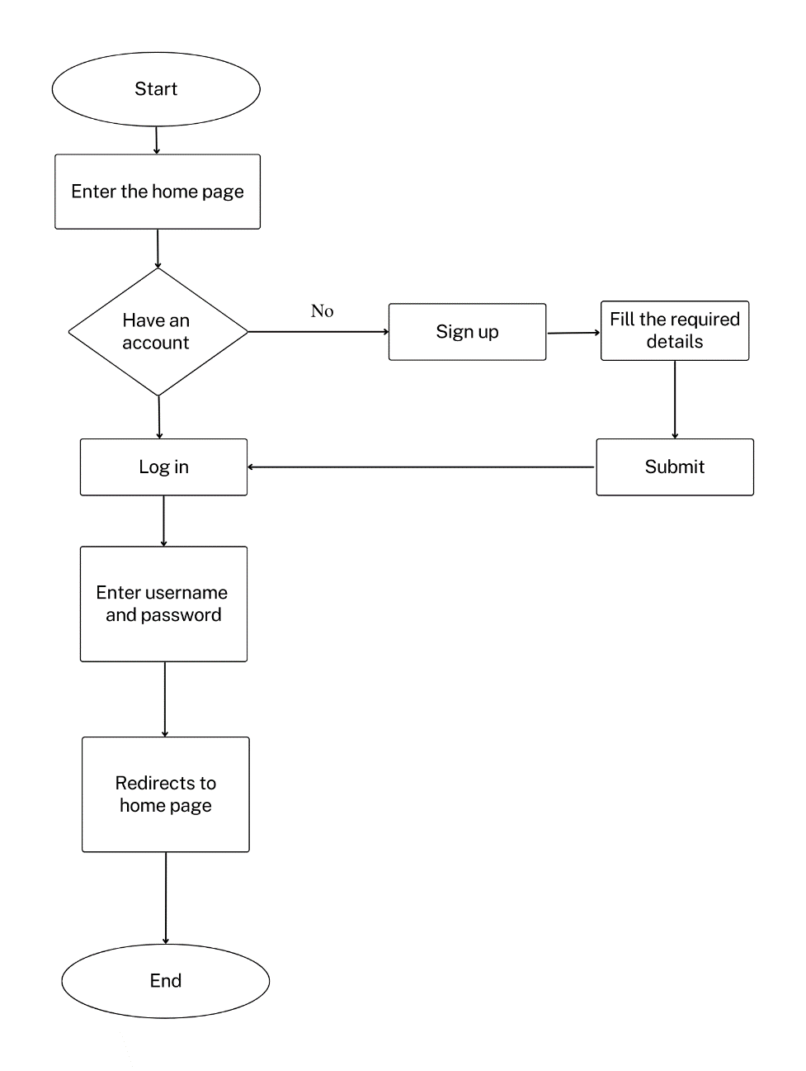

Fig 4.2. LOGIN PAGE

In this page we will be asking about the username and password of the user. Firstly the website validates the user inputs. It verifies the username and password by checking it with the usernames and passwords stored in the local storage when the user creates an account in the website.

### SIGNUP PAGE

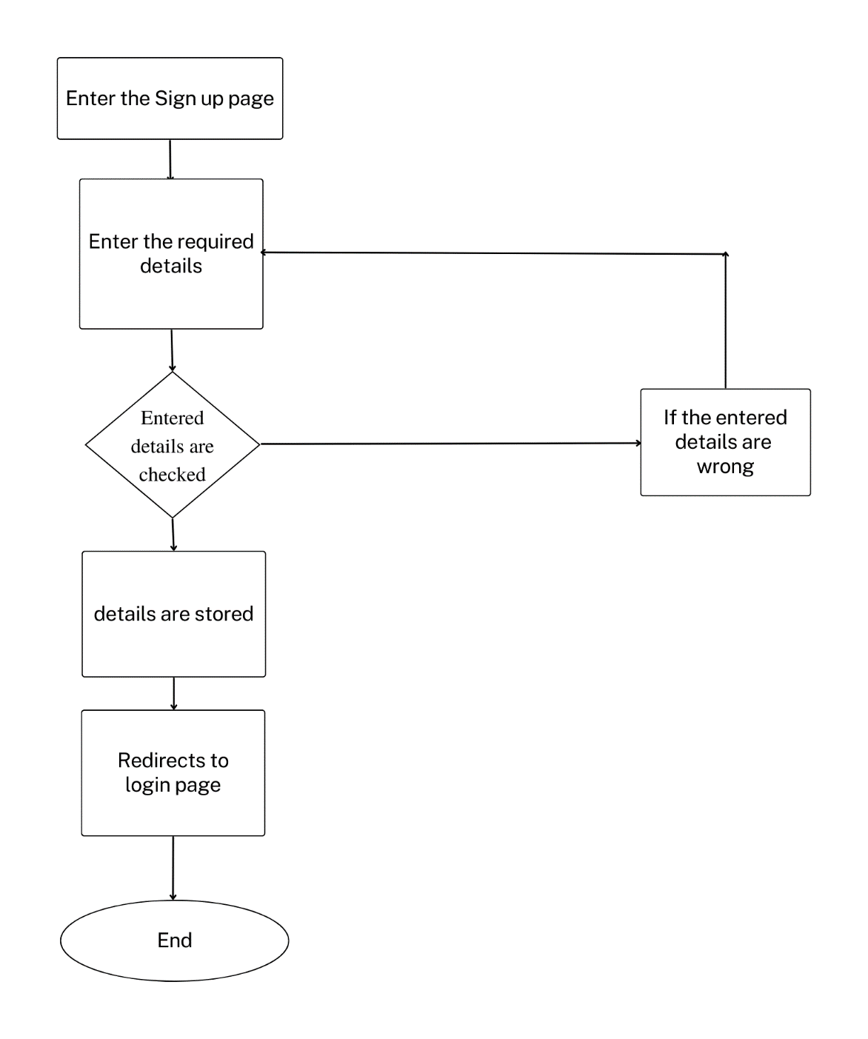

Fig 4.3 SIGNUP PAGE FLOWCHART

This page asks users about the basic details of the user to create an account. This page asks for details like username, password , email id, phone number. After the user enters the details , these details are then validated by our code . If all details are correct then the user is then directed to the login page

### MOBILES PAGE

This page displays the list of products available for sale. These details have been displayed from the list of products available in the javascript file named data.js. So that if we want to add some products to a particular product we can easily do it by adding the details to the products js file.

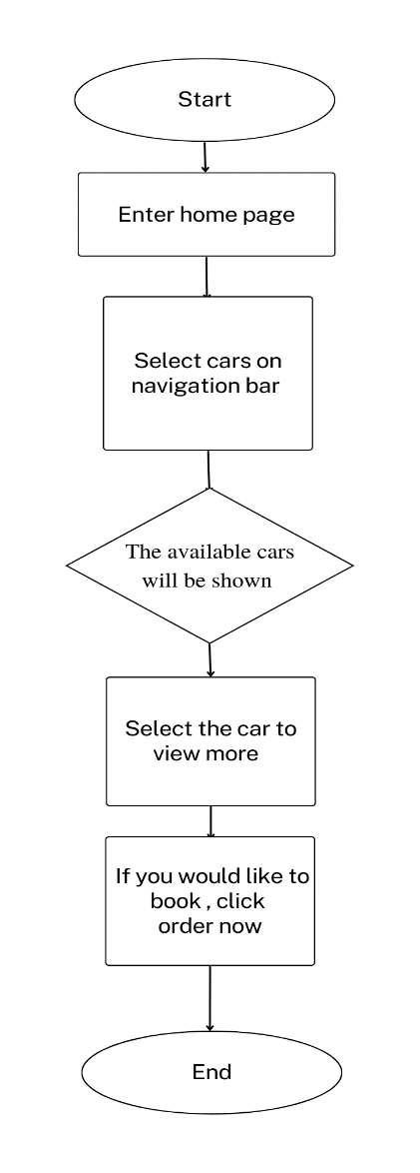

Fig 4.4 CARS PAGE FLOWCHART

### 4.4 PAYMENT PAGE

In this page you can complete the payment for the mobile. This is the final page of the website where you are able to pay for the mobile buying and have a receipt of it. Here you must enter the essential details for the processing of payment so careful while giving the credentials. This page requires name of the card holder, DOB, card number, expiry date.

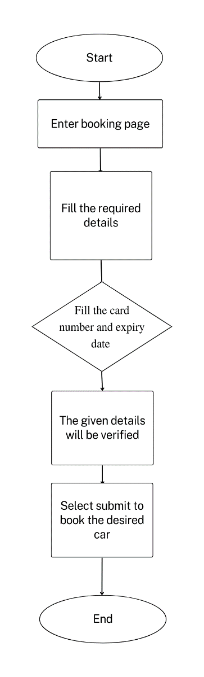

Fig 4.5 BOOKING PAGE FLOWCHART

# IMPLEMENTATION AND RESULT



### CHAPTER 5

### IMPLEMENTATION AND RESULT

This chapter gives a description about the output that we produced by developing the website of our idea.

### 5.1 LOGIN

When User enters our website he will be asked about his login details like email id and password. The login details will be verified with the details given while the user creates an account. The user needs to sign in in order to buy the mobiles.

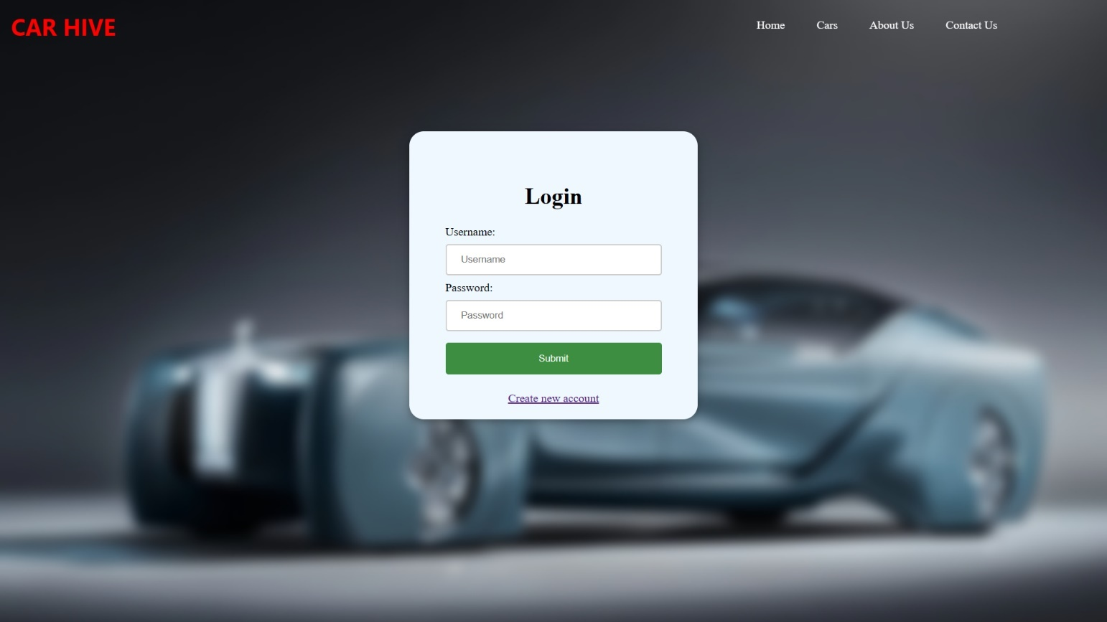

Fig 5.1 LOGIN PAGE

### 5.2 SIGN UP

If a user doesn’t have an account on the website, User can use a component named create new account available in the login page. When the user clicks on that he will be redirected to the signup page. In sign up he should fill up his email id, password and phone number. These inputs will be validated. If the given inputs are wrong , the details must be filled again in the fields respectively.

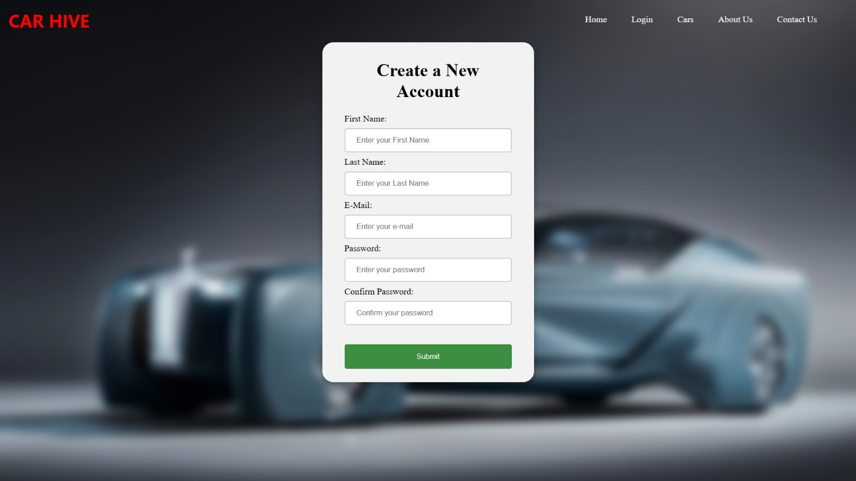

Fig 5.2 SIGNUP PAGE

### 5.3 MOBILES PAGE

Here the latest mobiles available in the market are given. Here you can search for your desired mobile and read their reference for each of them. They can be viewed detailed if you click more button. If you are interested you may buy the car. Here you may view the description of the mobile we have. You may redirect to the home page using the navigation bar on the top easily. The mobiles page gives you the overview of the cars we currently have at stock and can be booked by the customers. To see more details about the mobile like manufactured year, price you may click the more option to view more about the mobiles given.

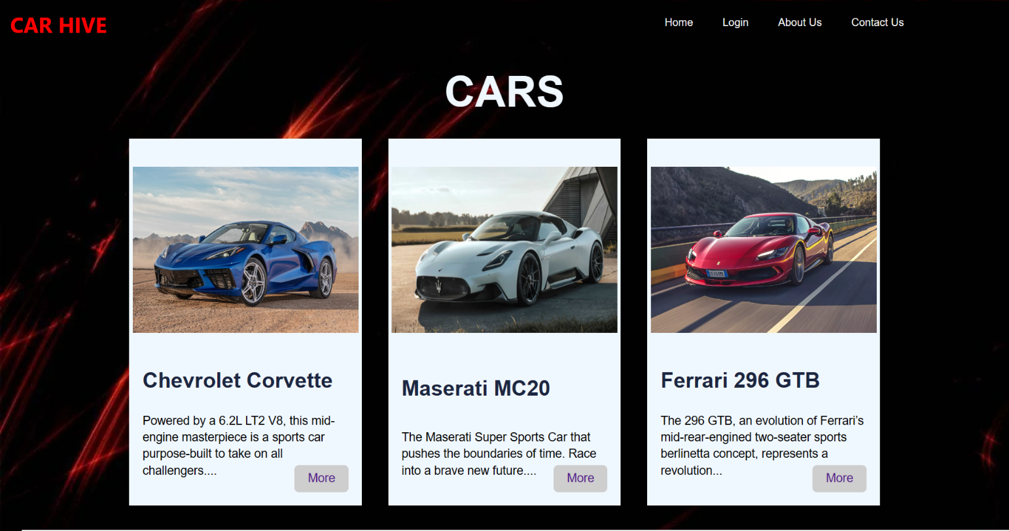

Fig 5.3 CARS PAGE

### 5.4 HOME PAGE

The webpage has different categories of mobiles available for sale and users can redirect to the mobiles description page by selecting the respective links. This page also contains the main taglines of the whole website idea. From the home page you can access all the pages of the website. You can access the about us page and even contact us page for any queries and complaint. Home page is the main page which connects all other pages like mobiles, login, about us, contact us. To view the mobiles you may click the to explore button in the home page or you may click the mobiles option in the navigation bar.

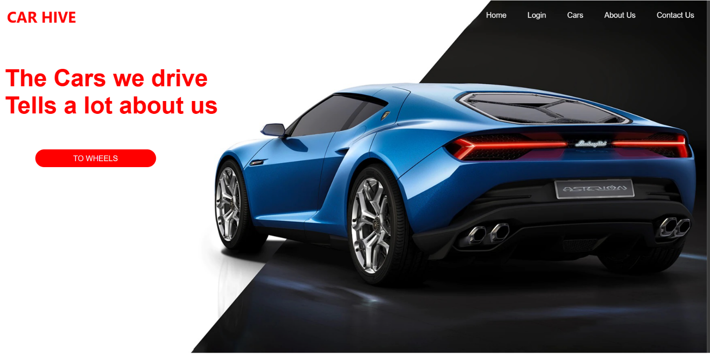

Fig 5.4 HOME PAGE

### 5.5 MOBILE DETAILS

This page displays the mobile’s specification and models available for sale. These details have been displayed from the list of products available in the page using css. So that if we want to add some products to the particular product we can easily do it by adding the details to the products jn file. Here you may view the mobile details like manufactured year , the price of the mobile , camera quality and more about the mobile from trusted source. We will only give correct information in the mobiles page which we have in stock .

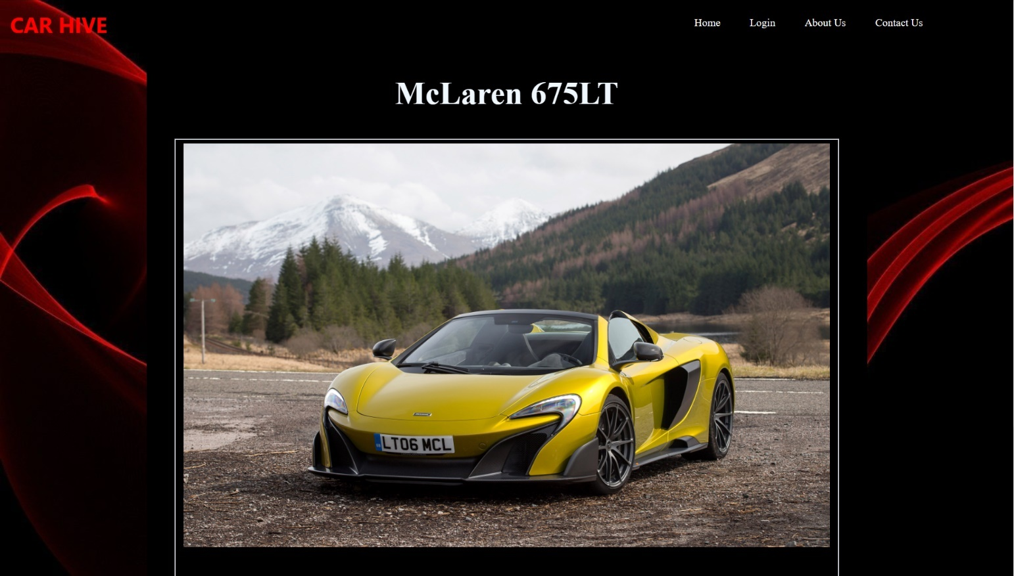

Fig 5.5 CAR DETAILS PAGE

### 5.6 PAYMENT PAGE

In this page you can finish the final step of the website. You can place order for the mobile by paying the advance amount here. Enter the required details correctly . So that the payment won.t go wrong . If you type the details wrong and made a payment the company won’t be responsible. This page requires details like name of the card holder, date of birth of the card holder to avoid any problems, card number of the account which will be processed for payment , expiration month and expiration year to verify the card. After processing these details your details will be checked and the ordering is complete.

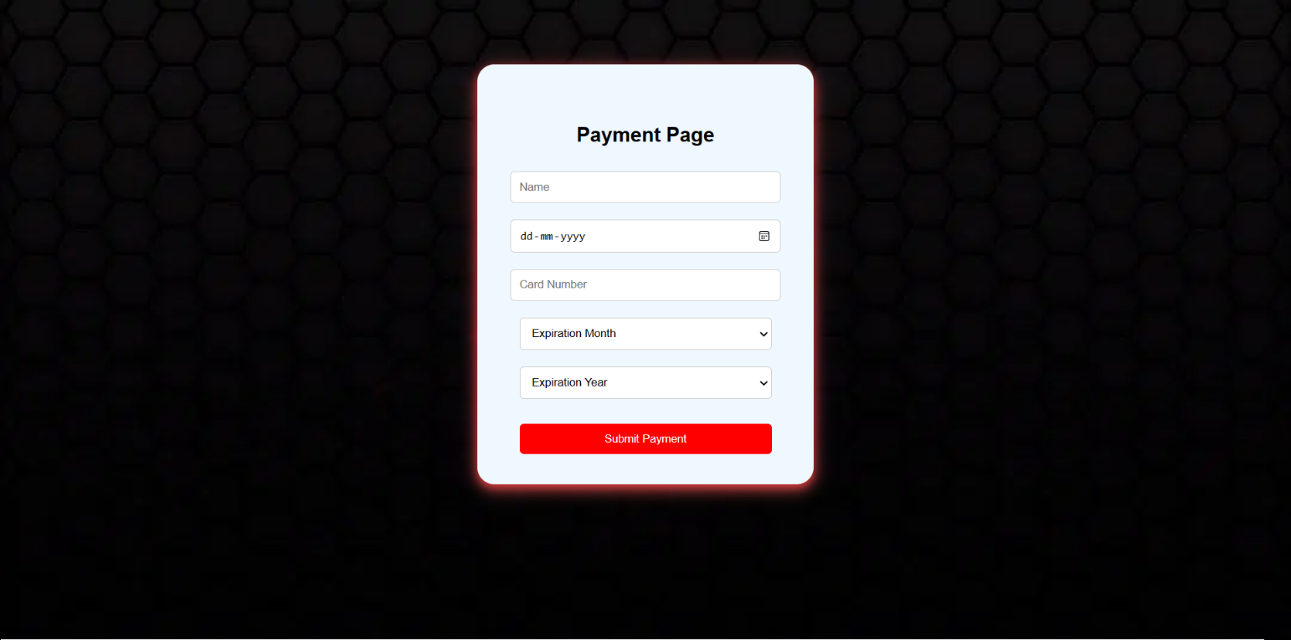

Fig 5.6 PAYMENT PAGE

### 5.7 CODING

**Login:**

Html:

<!DOCTYPE html>

<html>

<head>

<link rel="stylesheet" type="text/css" href="login.css">

</head>

<body>

<header>

<nav>

<p>CAR HIVE</p>

<ul>

<li><a href="C:\Users\ASUS\Desktop\Car Point\home.html">Home</a></li>

<li><a href="C:\Users\ASUS\Desktop\Car Point\vehicles.html">Cars</a></li>

<li><a href="C:\Users\ASUS\Desktop\Car Point\About page\aboutus.html">About Us</a></li>

<li><a href="C:\Users\ASUS\Desktop\Car Point\contact page\contactus.html">Contact Us</a></li>

</ul>

</nav>

</header>

<script src="login.js"></script>

<div id="login-container">

<form action="#">

<h1>Login</h1>

<label class="text">Username:</label>

<input type="text" id="username" placeholder="Username">

<label class="text">Password:</label>

<input type="password" id="password" placeholder="Password">

<input type="submit" id="submit-btn" value="Submit"><br>

<p><a href="#">Create new account</a></p>

</form>

</div>

</body>

</html>

CSS:

body{

background: url('login1.jpg');

background-size: cover;

}

nav{

position: fixed;

top: 0;

left: 0;

width: 100%;

display: flex;

align-items: right;

text-align: right;

}

.logo{

margin-left: 18px;

cursor: pointer;

}

nav p{

color: red;

font-family: system-ui, -apple-system, BlinkMacSystemFont, 'Segoe UI', Roboto, Oxygen, Ubuntu, Cantarell, 'Open Sans', 'Helvetica Neue', sans-serif;

font-weight: bolder;

font-size: 200%;

margin-left: 1%;

margin-top: 1%;

}

nav ul{

margin-left: 54%;

margin-top: 1%;

}

nav ul li{

display: inline-block;

margin: 10px 20px;

}

nav ul li a{

text-decoration: none;

color: white;

}

#login-container {

width: 300px;

height: 300px;

margin: 100px auto;

margin-top: 12%;

background-color:aliceblue;

padding: 50px;

text-align: left;

box-shadow: 0 4px 8px 0 rgba(0, 0, 0, 0.2), 0 6px 20px 0 rgba(0, 0, 0, 0.19);

border-radius: 20px;

}

h1,p{

text-align: center;

}

input[type=text], input[type=password] {

width: 100%;

padding: 12px 20px;

margin: 8px 0;

box-sizing: border-box;

border: 2px solid #ccc;

border-radius: 4px;

}

#submit-btn {

width: 100%;

background-color:red;

color: white;

padding: 14px 20px;

margin: 8px 0;

border: none;

border-radius: 4px;

cursor: pointer;

}

#submit-btn {

background-color: #3e8e41;

}

### Sign up:

HTML:

<!DOCTYPE html>

<html lang="en">

<head>

<meta charset="UTF-8">

<meta http-equiv="X-UA-Compatible" content="IE=edge">

<meta name="viewport" content="width=device-width, initial-scale=1.0">

<title>Car Point</title>

<link rel="stylesheet" href="newacc.css">

</head>

<body>

<header>

<nav>

<p>CAR HIVE</p>

<ul>

<li><a href="C:\Users\ASUS\Desktop\Car Point\home.html">Home</a></li>

<li><a href="C:\Users\ASUS\Desktop\Car Point\Login 1\login.html">Login</a></li>

<li><a href="C:\Users\ASUS\Desktop\Car Point\vehicles.html">Cars</a></li>

<li><a href="C:\Users\ASUS\Desktop\Car Point\About page\aboutus.html">About Us</a></li>

<li><a href="C:\Users\ASUS\Desktop\Car Point\contact page\contactus.html">Contact Us</a></li>

</ul>

</nav>

</header>

<div class="login-container">

<h1>Create a New Account</h1>

<form action="#" method="post">

<label for="fname">First Name:</label><br>

<input type="text" id="fname" name="fname" placeholder="Enter your First Name" required><br>

<label for="lname">Last Name:</label><br>

<input type="text" id="lname" name="lname" placeholder="Enter your Last Name" required><br>

<label for="email">E-Mail:</label><br>

<input type="email" id="email" name="email" placeholder="Enter your e-mail" required><br>

<label for="password">Password:</label><br>

<input type="password" id="password" name="password" placeholder="Enter your password" required><br>

<label for="Cpassword">Confirm Password:</label><br>

<input type="password" id="cpassword" name="password" placeholder="Confirm your password" required><br><br>

<input type="submit" id="submit-btn" value="Submit"><br>

</form>

</div>

</body>

</html>

CSS:

body{

background: url('login1.jpg');

background-size: cover;

}

nav{

position: fixed;

top: 0;

left: 0;

width: 100%;

display: flex;

align-items: right;

text-align: right;

}

.logo {

margin-left: 18px;

cursor: pointer;

}

nav p {

color: red;

font-family: system-ui, -apple-system, BlinkMacSystemFont, 'Segoe UI', Roboto, Oxygen, Ubuntu, Cantarell, 'Open Sans', 'Helvetica Neue', sans-serif;

font-weight: bolder;

font-size: 200%;

margin-left: 1%;

margin-top: 1%;

}

nav ul{

margin-left: 54%;

margin-top: 1%;

}

nav ul li{

display: inline-block;

margin: 10px 20px;

}

nav ul li a{

text-decoration: none;

color: white;

}

.login-container {

width: 300px;

height: 600px;

margin: 100px auto;

margin-top: 5%;

background-color: #f2f2f2;

padding-left: 40px;

padding-right: 40px;

padding-top: 10px;

text-align: left;

box-shadow: 0 4px 8px 0 rgba(0, 0, 0, 0.2), 0 6px 20px 0 rgba(0, 0, 0, 0.19);

border-radius: 20px;

}

h1,p{

text-align: center;

}

input[type=text], input[type=password],input[type=email] {

width: 100%;

padding: 12px 20px;

margin: 8px 0;

box-sizing: border-box;

border: 2px solid #ccc;

border-radius: 4px;

}

#submit-btn {

width: 100%;

background-color:red;

color: white;

padding: 14px 20px;

margin: 8px 0;

border: none;

border-radius: 4px;

cursor: pointer;

}

#submit-btn {

background-color: #3e8e41;

}

### Cars page:

<!DOCTYPE html>

<html lang="en">

<head>

<meta charset="UTF-8">

<meta http-equiv="X-UA-Compatible" content="IE=edge">

<meta name="viewport" content="width=device-width, initial-scale=1.0">

<title>CarHive</title>

<link rel="stylesheet" href="./Cars.css">

</head>

<body>

<header>

<nav>

<p>CAR HIVE</p>

<ul>

<li><a href="C:\Users\ASUS\Desktop\Car Point\home.html">Home</a></li>

<li><a href="C:\Users\ASUS\Desktop\Car Point\New login\log1.html">Login</a></li>

<li><a href="C:\Users\ASUS\Desktop\Car Point\New about us\nb1.html">About Us</a></li>

<li><a href="C:\Users\ASUS\Desktop\Car Point\New contact\nc1.html">Contact Us</a></li>

</ul>

</nav>

</header>

<div class="container">

<div class="header">

<h1>Cars</h1>

</div>

<div class="products">

<div class="product">

<div class="image">

<img src="./2020-Corvette-DSC_9208.webp">

</div>

<div class="namePrice">

<h3>Chevrolet Corvette</h3>

</div>

<p>Powered by a 6.2L LT2 V8, this mid-engine masterpiece is a sports car purpose-built to take on all challengers....</p>

<div class="buy">

<button><a href="./vehicles.html">More</a></button>

</div>

</div>

<div class="product">

<div class="image">

<img src="./novitec-maserati-mc20-2022.jpg">

</div>

<div class="namePrice">

<h3>Maserati MC20</h3>

</div>

<p>The Maserati Super Sports Car that pushes the boundaries of time. Race into a brave new future....</p>

<div class="buy">

<button><a href="./vehicles.html">More</a></button>

</div>

</div>

<div class="product">

<div class="image">

<img src="./ferrari-269-gtb-sexiest-version-sustainable-can-buy-01.webp">

</div>

<div class="namePrice">

<h3>Ferrari 296 GTB</h3>

</div>

<p>The 296 GTB, an evolution of Ferrari’s mid-rear-engined two-seater sports berlinetta concept, represents a revolution...</p>

<div class="buy">

<button><a href="./vehicles.html">More</a></button>

</div>

</div>

<div class="product">

<div class="image">

<img src="./2019-Jaguar-F-Type-SVR-SILVER-4974-1.jpg">

</div>

<div class="namePrice">

<h3>Jaguar F-Type SVR</h3>

</div>

<p>Electronic Torque Vectoring by Braking delivers agility and capability through the corners....</p>

<div class="buy">

<button><a href="./vehicles.html">More</a></button>

</div>

</div>

<div class="product">

<div class="image">

<img src="./2017-McLaren-675LT-Spider-006-1600.jpg">

</div>

<div class="namePrice">

<h3>McLaren 675LT</h3>

</div>

<p>Experience the raw adrenaline of the 675LT, the lightest, most driver-focused, most exclusive series...</p>

<div class="buy">

<button><a href="./vehicles.html">More</a></button>

</div>

</div>

<div class="product">

<div class="image">

<img src="./2005_LotusSport_Exige240R1.jpg">

</div>

<div class="namePrice">

<h3>Lotus Sport Exige 240R</h3>

</div>

<p>With a supercharged and intercooled high revving engine producing over 240 bhp and over 170 lb-ft of torque...</p>

<div class="buy">

<button><a href="./vehicles.html">More</a></button>

</div>

</div>

</div>

</div>

</body>

</html>

CSS:

body{

min-height: 100vh;

display: grid;

place-content: center;

background: url('wp2718317.webp');

}

nav{

position:absolute;

top: 0;

left: 0;

width: 100%;

display: flex;

align-items: right;

text-align: right;

}

nav p{

color: red;

font-family: system-ui, -apple-system, BlinkMacSystemFont, 'Segoe UI', Roboto, Oxygen, Ubuntu, Cantarell, 'Open Sans', 'Helvetica Neue', sans-serif;

font-weight: bolder;

font-size: 200%;

margin-left: 1%;

margin-top: 1%;

}

nav ul{

margin-left: 54%;

margin-top: 1%;

}

nav ul li{

display: inline-block;

margin: 10px 20px;

}

nav ul li a{

text-decoration: none;

color: white;

}

.content{

color: white;

position: absolute;

margin-left: 19%;

margin-top: 7%;

}

.content h1{

color: white;

font-size: 50px;

}

.links{

position: absolute;

margin-top: 42%;

margin-left: 40%;

}

.links .order{

padding: 10px 80px;

text-decoration: none;

color: rgb(37, 37, 37);

background-color:#fff;

}

*{

padding: 0;

margin: 0;

box-sizing: border-box;

font-family:Arial, Helvetica, sans-serif;

}

.container{

width: 80vw;

height:80vh;

display: flex;

flex-direction: column;

justify-content: space-around;

}

.header{

width: 100%;

text-align: center;

}

.header h1{

font-size: 4em;

text-transform: uppercase;

color:aliceblue;

}

.products{

width: 100%;

align-self: center;

height: 80%;

display: flex;

justify-content: center;

flex-wrap: wrap;

gap: 40px;

}

.product{

position: relative;

background-color:aliceblue;

width: 350px;

height: 100%;

box-shadow: 0 5px 20px rgba(0, 0, 0, .3);

display: flex;

flex-direction: column;

justify-content: space-between;

padding: 20px 20px 40px;

transition: .3s;

}

.product:hover{

transform: translateY(-15px);

box-shadow: 10px 5px 10px rgba(255, 68, 68, 0.814);

}

.image{

width:100%;

height: 60%;

display: grid;

place-content: center;

}

.image img{

width: 340px;

height:250px;

}

.namePrice{

width: 100%;

font-weight: 250;

display: flex;

justify-content: space-between;

}

.namePrice h3{

font-size: 2em;

text-transform: capitalize;

color: #1b2741 ;

}

.namePrice span{

font-size: 1.5em;

color: #f67034;

}

.product p{

font-size: 18px;

line-height: 25px;

}

.buy{

position: absolute;

bottom: 20px;

right: 20px;

text-decoration-color: aliceblue;

text-decoration: none;

}

.buy button{

padding: 10px 20px;

border-radius: 7px;

border: none;

background-color:#cecece;

color:aliceblue;

font-size: 18px;

text-transform: capitalize;

cursor: pointer;

transition: .5s;

}

.buy button:hover{

transform: scale(1.1);

background-color: red;

color: aliceblue;

}

.buy button a{

text-decoration: none;

}

### Home page:

**HTML:**

<!DOCTYPE html>

<html lang="en">

<head>

<meta charset="UTF-8">

<meta http-equiv="X-UA-Compatible" content="IE=edge">

<meta name="viewport" content="width=device-width, initial-scale=1.0">

<title>Car Point</title>

<link rel="stylesheet" href="home.css">

</head>

<body>

<header>

<nav>

<p>CAR HIVE</p>

<ul>

<li><a href="C:\Users\ASUS\Desktop\Car Point\home.html">Home</a></li>

<li><a href="C:\Users\ASUS\Desktop\Car Point\Login 1\login.html">Login</a></li>

<li><a href="C:\Users\ASUS\Desktop\Car Point\vehicles.html">Cars</a></li>

<li><a href="C:\Users\ASUS\Desktop\Car Point\About page\aboutus.html">About Us</a></li>

<li><a href="C:\Users\ASUS\Desktop\Car Point\contact page\contactus.html">Contact Us</a></li>

</ul>

</nav>

</header>

<div class="content">

<h1>The Cars we drive <br>Tells a lot about us</h1>

</div>

<div class="links">

<a class="order" href="C:\Users\ASUS\Desktop\Car Point\vehicles.html" >TO WHEELS</a>

</div>

</body>

</html>

**CSS:**

body{

font-family: Arial, Helvetica, sans-serif;

margin: 0;

padding: 0;

background: url('asterion1.jpg');

background-size: 110%;

background-repeat: no-repeat;

}

nav{

position: fixed;

top: 0;

left: 0;

width: 100%;

display: flex;

align-items: right;

text-align: right;

}

nav p{

color: red;

font-family: system-ui, -apple-system, BlinkMacSystemFont, 'Segoe UI', Roboto, Oxygen, Ubuntu, Cantarell, 'Open Sans', 'Helvetica Neue', sans-serif;

font-weight: bolder;

font-size: 200%;

margin-left: 1%;

margin-top: 1%;

}

nav ul{

margin-left: 54%;

margin-top: 1%;

}

nav ul li{

display: inline-block;

margin: 10px 20px;

}

nav ul li a{

text-decoration: none;

color: white;

}

.content{

color: white;

position: absolute;

margin-top: 7%;

}

.content h1{

color: red;

font-size: 50px;

text-align:left;

margin-left: 10px;

}

.links{

position: absolute;

margin-top: 22%;

margin-left: 5%;

}

.links .order{

padding: 10px 80px;

text-decoration: none;

color:aliceblue;

background-color:red;

border-radius: 30px;

}

# CONCLUSION



## CHAPTER 7

## CONCLUSION

### CONCLUSION

The platform has great potential to improve its online presence and drive sales through a range of strategies and technologies. The proposed system outlined in this report is designed to enhance the user interface, expand product offerings, streamline financing options, improve customer service and support, and utilize customer feedback. By implementing these changes, the website can offer customers a convenient and seamless online car buying experience, while also improving its competitiveness in the market. With the right strategy and technology, the website can realize its full potential and become a leader in the online mobile selling market.

### FUTURE SCOPE

Implementing algorithms that can provide personalized mobile recommendations based on the customer's needs and preferences. In an increasingly mobile world, it is crucial for the website to have a responsive design that works seamlessly on all devices. Ensuring that the website is optimized for mobile devices and can be easily accessed and navigated through mobile devices. Integrating secure payment systems to allow customers to make online transactions with ease. Implementing real-time inventory management systems to keep track of car availability and streamline the mobile buying process.

# REFERENCES

### REFERENCES

1. National Automobile Dealers Association (NADA): www.nada.org.

2. J.D. Power: www.jdpower.com

3. Automotive News: www.autonews.com

4. Dealertrack Technologies: www.dealertrack.com

5. Digital Dealer: www.digitaldealer.com